# Customer Meeting

Customer meeting date to demo this iteration.

Our next meeting with the client is on 26-April-2022 at 4:45 pm

### Meeting notes from the previous client meeting:

* Demo for the previous iteration
* No comments or changes request

## User Stories Implemented

User stories are implemented in this iteration.

User stories we implemented in this iteration are:

1. User Story: As a host, during the event I wish to see the overall position of the different users on the privilege walk
2. User story: As a participant, when I finish the activity I wish to see my final position on the graph in relation to other participants
3. User Story: As a participant, I wish to see how many people have responded to a question so far, to see how many people are participating in the study.
4. User Story: As a host, during the event I wish to see the distribution of answers for the current question.
5. User Story: As a host, once everyone has answered all questions, I wish to be able to see the position of everyone on the graph.

We have implemented all the user stories we planned to implement for this iteration.

# TESTS

## Backend

**Results:** BDDs test results for backend apis

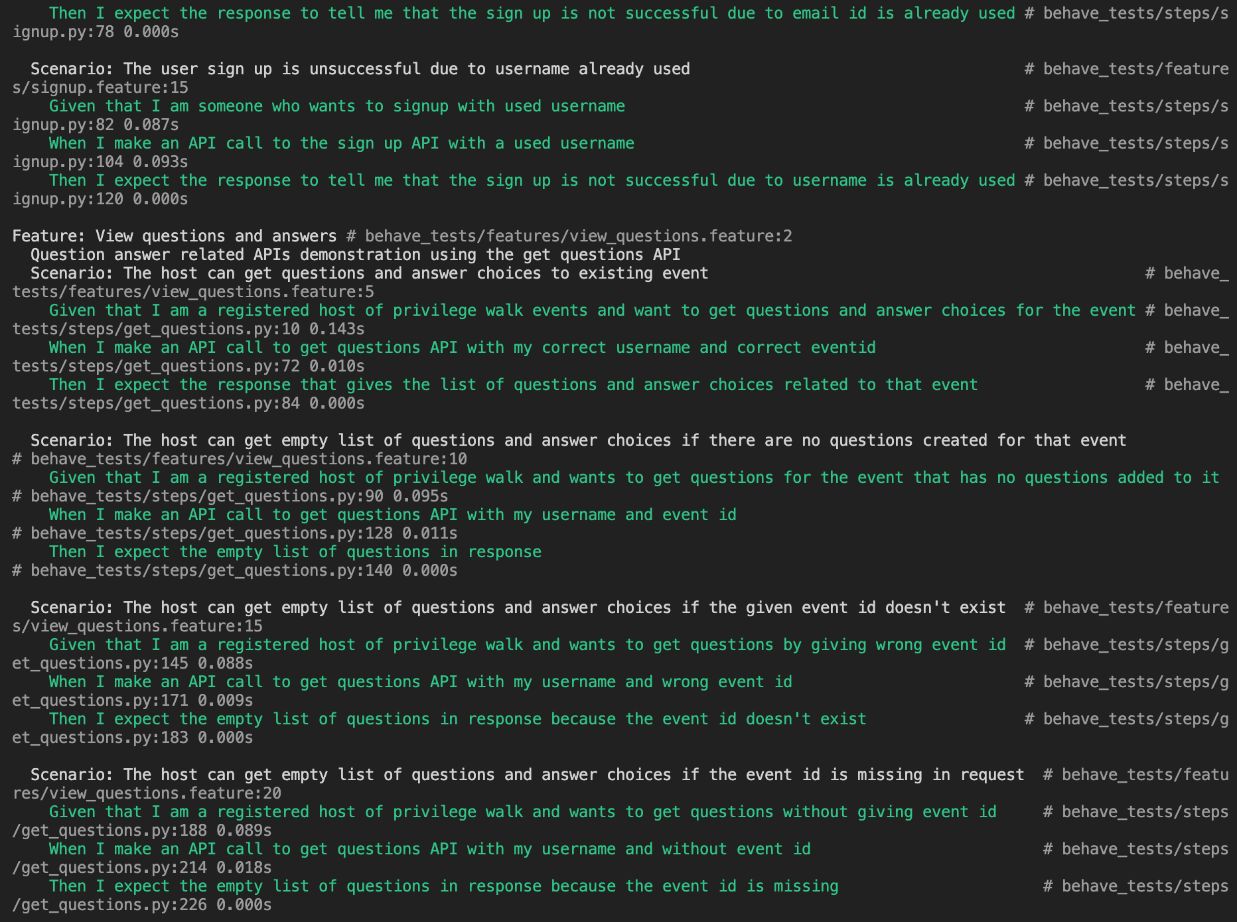

Backend TDDs

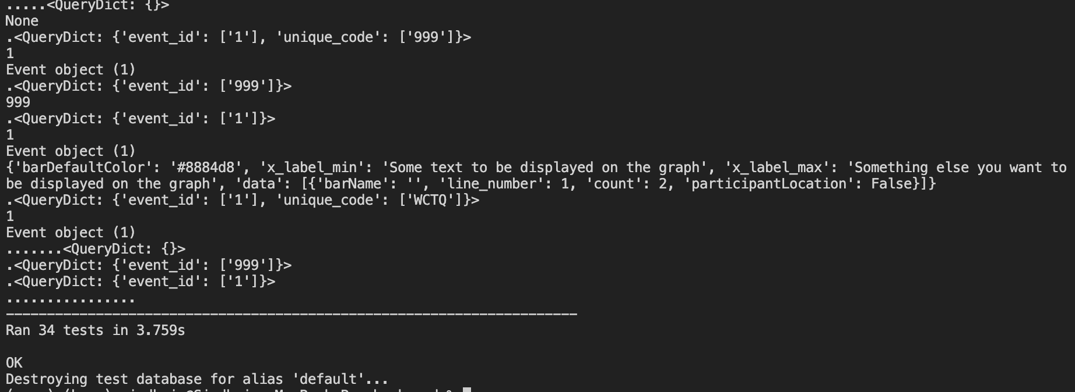

**Coverage:** Backend tests with 98% coverage.

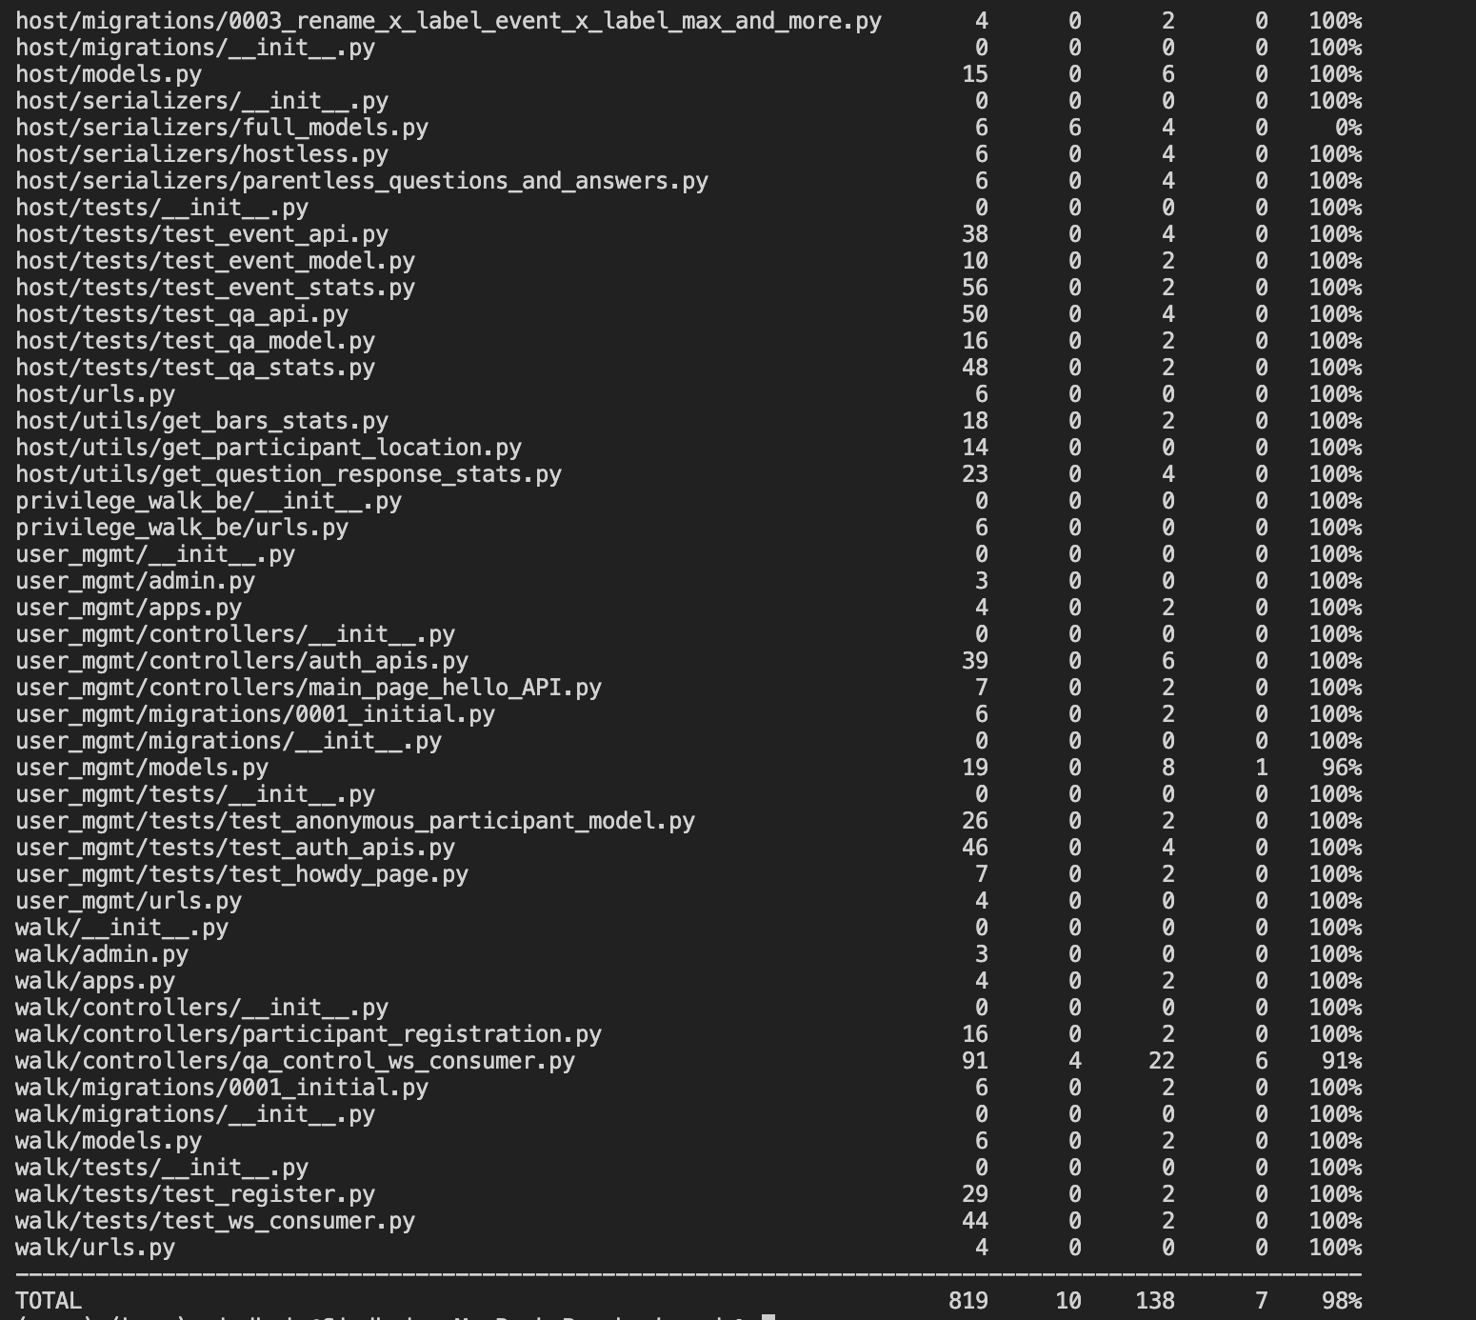

The instructions to get coverage report is mentioned in ReadMe of repo: <https://github.com/Privilege-walk/back-end.git>

Steps to Run backend tests:

1. Git clone the backend repo
   1. git clone https://github.com/Privilege-walk/back-end.git
2. Install requirements
   1. Look at the Running instructions mentioned in ReadMe at <https://github.com/Privilege-walk/back-end.git>
   2. Once you create and activate virtualenv install the requirements using command
      1. pip3 install -r requirements.txt
3. Run BDDs
   1. We used ‘behave’ to create BDDs for the features and scenarios as we are developing backend in Django
   2. The BDDs can be run at once by using below command:
      1. python manage.py behave
4. Run TDDs
   1. All the TDDs for all apis scenarios can be tested using the command
      1. python manage.py test

For more detailed explanation on instructions to run tests for backend are mentioned in ReadMe of the repo: <https://github.com/Privilege-walk/back-end.git>

## FRONTEND

**TDDs:**

**Coverage**: TDDs frontend test coverage

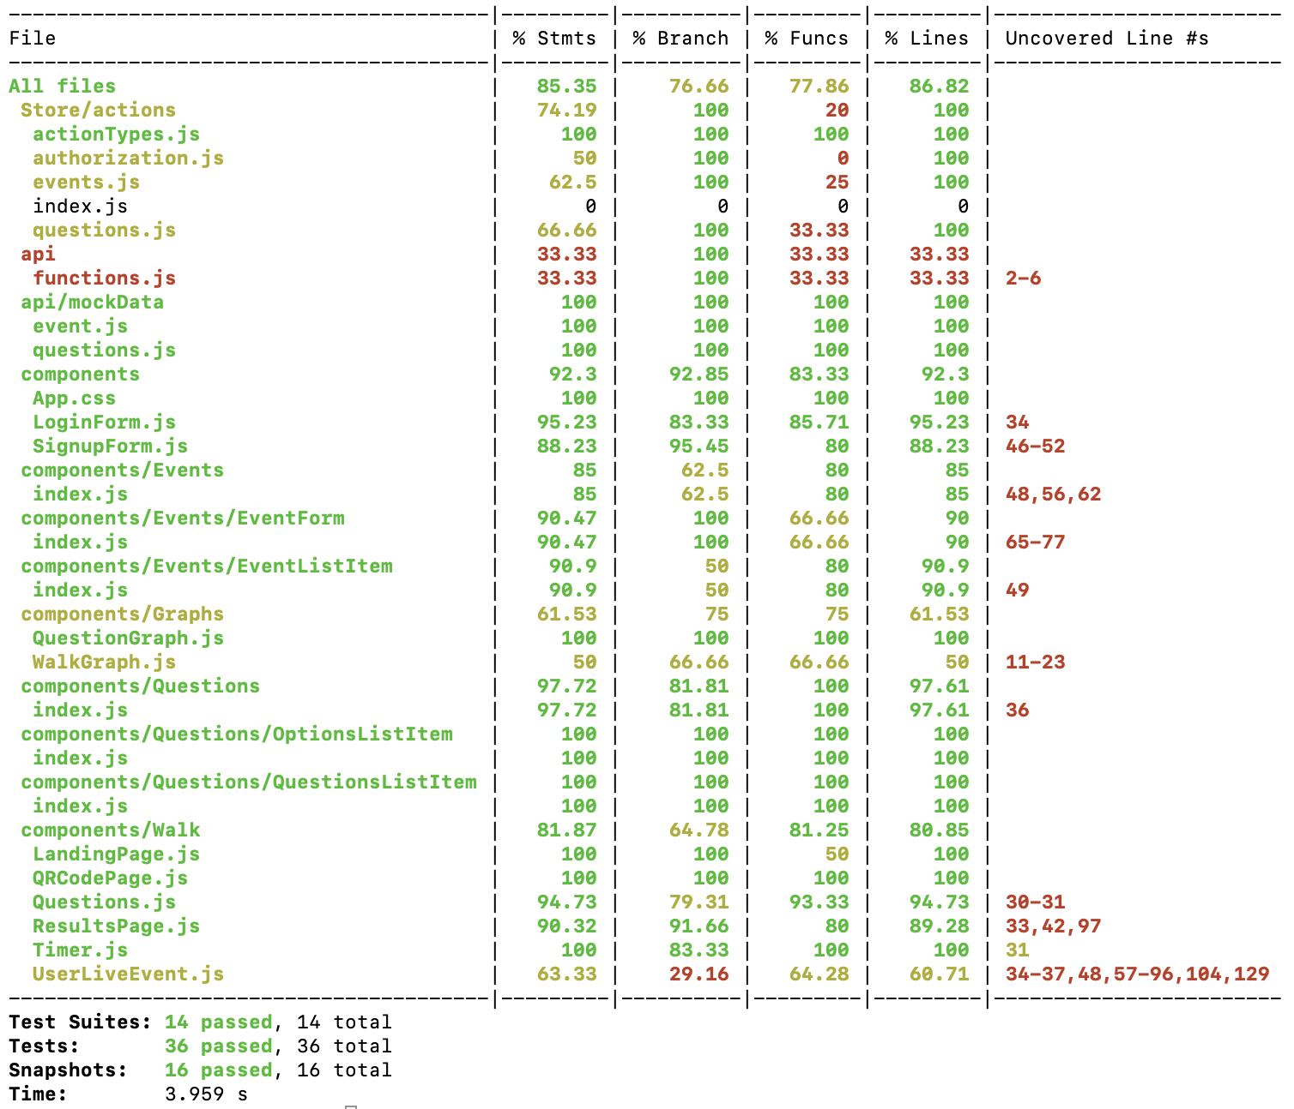

**Results:** for TDDs

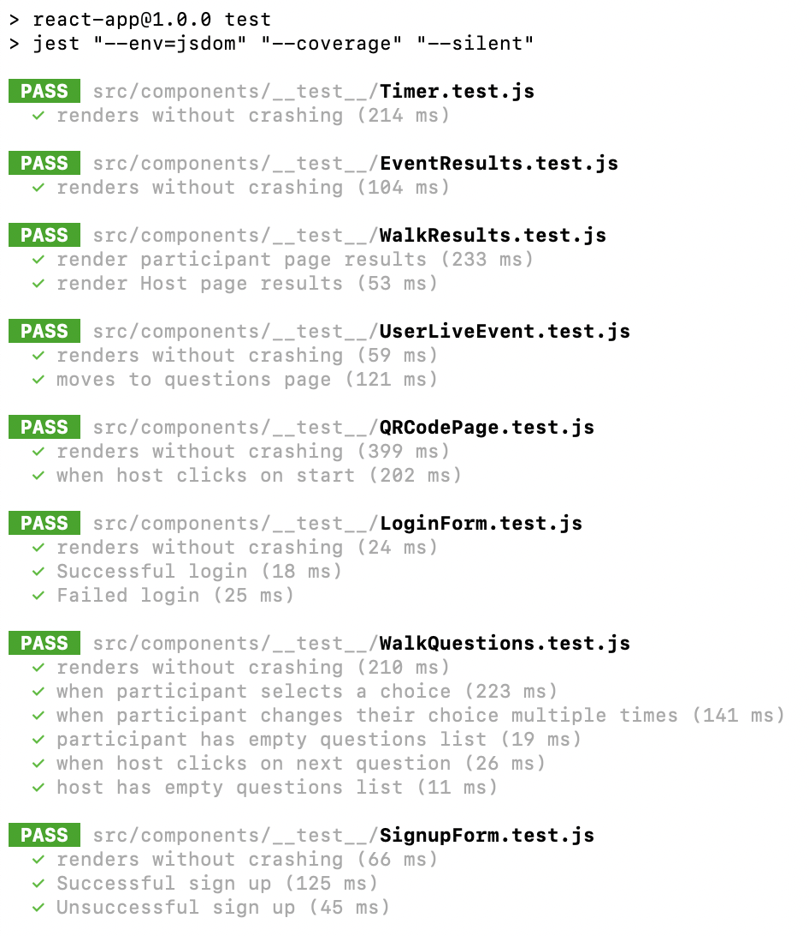

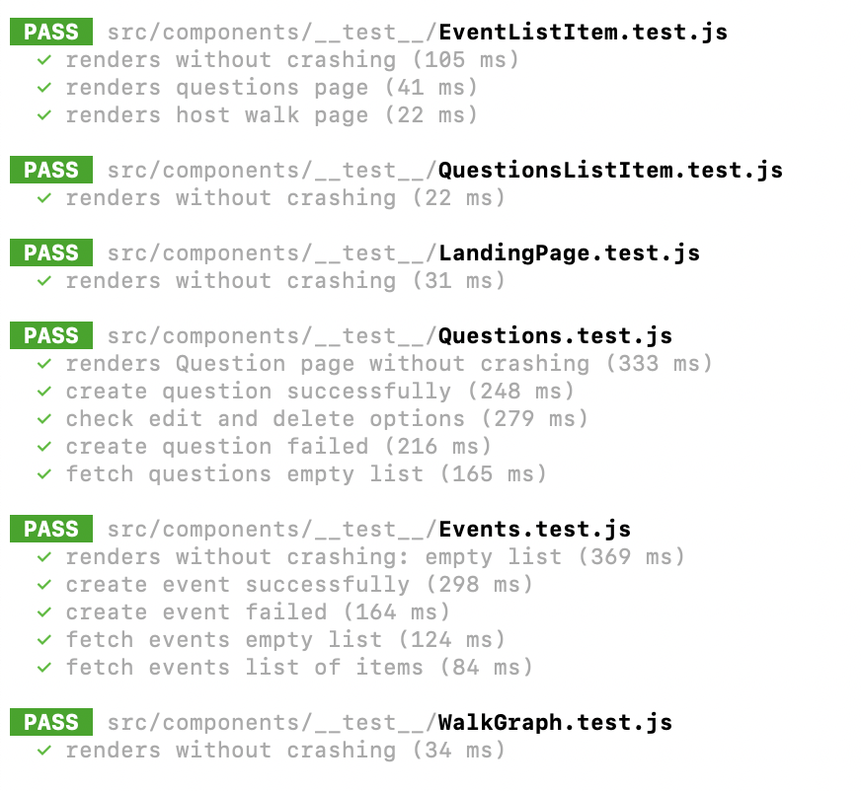

**BDDs**

**Results:**

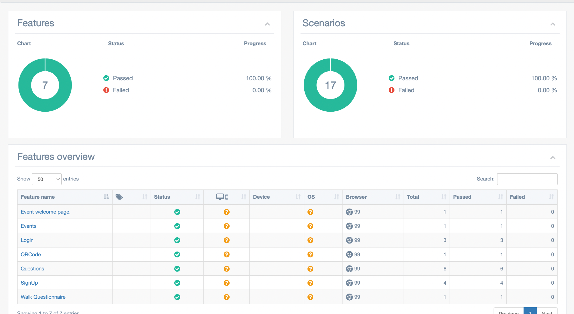

**STEPS**

Steps to Run frontend tests:

1. Clone the repository and switch to the root of the repository.
   1. git clone <https://github.com/Privilege-walk/front-end.git>
   2. cd front-end
2. Install npm packages.
   1. npm install
3. RUN TDDs.
   1. npm run test
4. RUN BDDs
   1. Make sure frontend is up by running.
      1. npm start
   2. Make sure the back-end is running by (I’m assuming you’ve cloned the backend repository and installed requirements. See steps 1 and 2 below in “Steps to Run backend tests”):
      1. python manage.py runserver
   3. Run BDD tests by running.
      1. npm run test-bdd

For more detailed steps please checkout README for frontend: https://github.com/Privilege-walk/front-end/blob/main/README.md

# LINKS

Pivotal Tracker: <https://www.pivotaltracker.com/n/projects/2556087>

GitHub Repo Backend: <https://github.com/Privilege-walk/back-end>

GitHub Repo Frontend: <https://github.com/Privilege-walk/front-end>  
GitHub Repo Project: <https://github.com/Privilege-walk/privilege-walk>  
Heroku Deployment backend(old): <https://privilegewalkbe.herokuapp.com/>  
Heroku Deployment project: <https://privilegewalk.herokuapp.com/>

Backend deployed in AWS and is available at: <http://54.157.248.16:8000/>  
Code Climate Frontend: <https://codeclimate.com/github/Privilege-walk/front-end>

Code Climate Backend: <https://codeclimate.com/github/Privilege-walk/back-end>